Project Documentation

1. Introduction

Project Title: AI WEATHER WISE

Team ID:[ SWTID-2026-2456]

Team Leader: [NIHARIKAA K & 24csniharikaa.k063@gmail.com]

Team Members:

[NIVEDHA L & 24csnivedha64@gmail.com]
[NAVANEETHA Y & 24csnavaneethay61@gmail.com]
[NETHRA R & 24csnethrar062@gmail.com]
[NIVEDITHA R & 24csniveditha065@gmail.com]

2. Project Overview

- Purpose:

AI Weather Wise is a robust RESTful backend platform built with Node.js and Express.js, utilizing MongoDB and Mongoose ODM for data persistence.
It delivers real-time weather metrics integrated with Google Gemini AI to provide intelligent summaries and personalized the recommendations based on live environmental conditions.

- Features:

- Real-time weather data retrieval.
- AI-powered weather summaries and personalized recommendations using Google Gemini.
- Favorite location management with CRUD operations.
- Secure user authentication using JWT and bcrypt password hashing.
- Role-based access control for protected resources.
- MongoDB database management using Mongoose.
- Centralized error handling and request sanitization.
- Fallback mode when external API keys are unavailable.

3. Architecture

- Interface: API tools like Thunder client query distinct route paths to extract JSON entities.

- Express Server Gateway: Handles HTTP methods (GET, POST, PUT, DELETE), JSON payloads, and CORS headers.

- Authentication & Role Matrix Middleware: Validates user authentication tokens and manages authorization for protected resources.

- Database Interface Layer: Mongoose translates application logic into MongoDB queries.

- AI Service Integration: Uses @google/generative-ai to generate weather summaries and personalized recommendations based on live temperature and weather conditions.

4. Setup Instructions

Prerequisites:

- Node.js
- MongoDB
- Npm
- Gemini AI SDK
- Thunder client
- Visual Studio Code

Installation Steps:

# Create the project folder
Create a new folder named AI Weatherwise

# Open the project folder
Open the project folder in Visual Studio Code

# Initialize the project
Npm init -y

# Install the required dependencies
Npm install express mongoose bcryptjs jsonwebtoken cors dotenv multer @google/genai

# Install Nodemon for development
Npm install –save-dev nodemon

5. Folder Structure

AI Weatherwise/
|-- index.js
|-- .env
|-- package.json
|-- .gitignore

6. Running the Application

Backend:
Npm install
Npm start
API Testing: The backend REST APIs can be tested using Thunder Client.

7. API Documentation

User Management:
POST /api/user/register
POST /api/user/login
Weather:
GET /api/weather

Recommendation:
POST /api/recommendation

8. Authentication

- JWT-based authentication is used for secure user authentication.

- Middleware validates authentication tokens and manages authorization for protected resources.

- Role-based access control is provided for authorized users.

9. User Interface

- API tools like Thunder client are used to query distinct route paths and extract JSON entities.

- The interface layer functions as an API Routing Layer in the headless backend service.

- Network requests are linked to their associated controller handler logic.

10. Testing

- The AI Weather Wise backend can be tested using Thunder Client.

- API testing is performed for Register, Login, Weather, and Recommendation APIs.

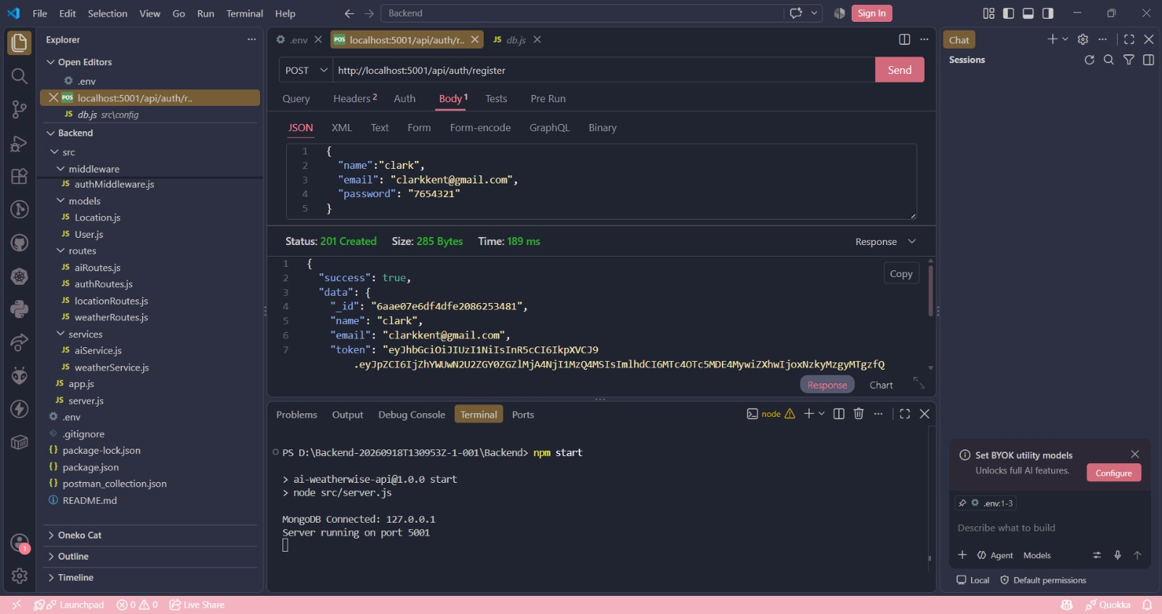
11. Screenshots

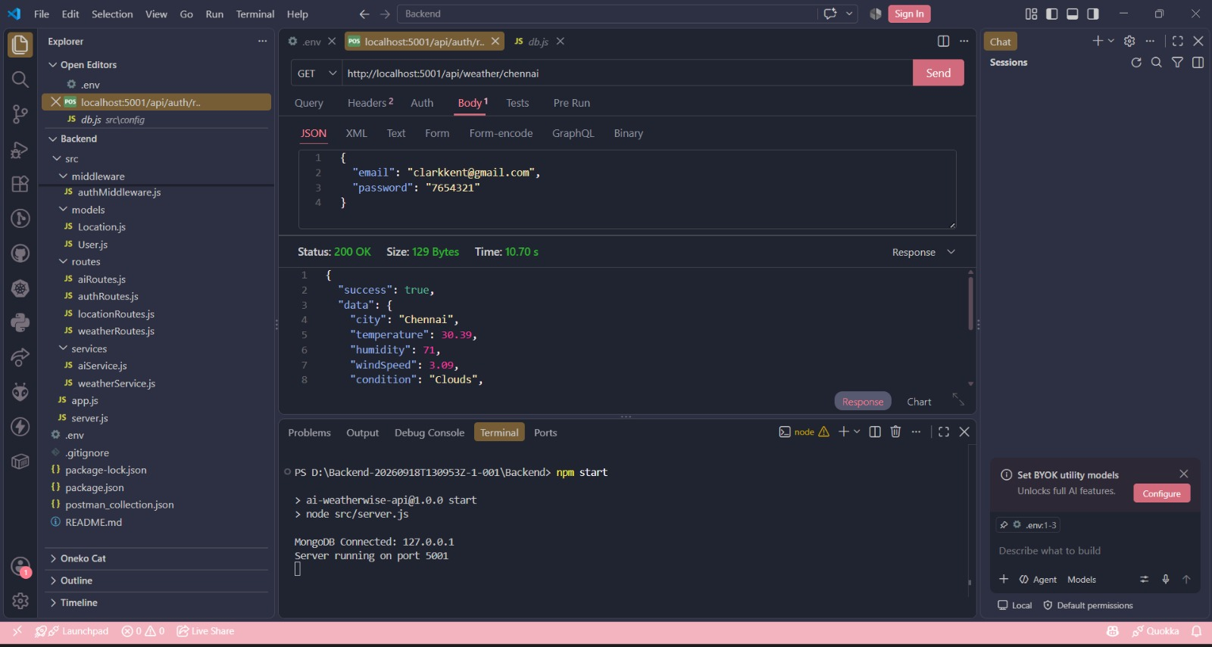

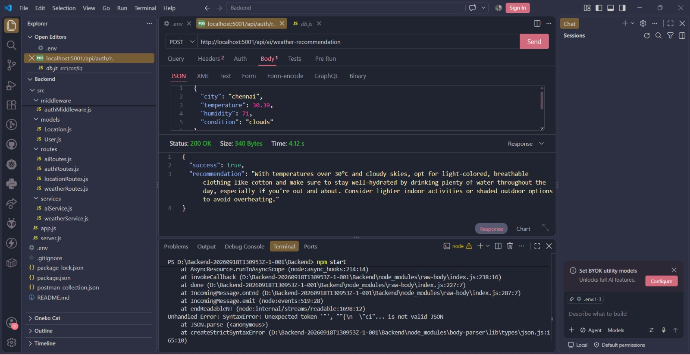

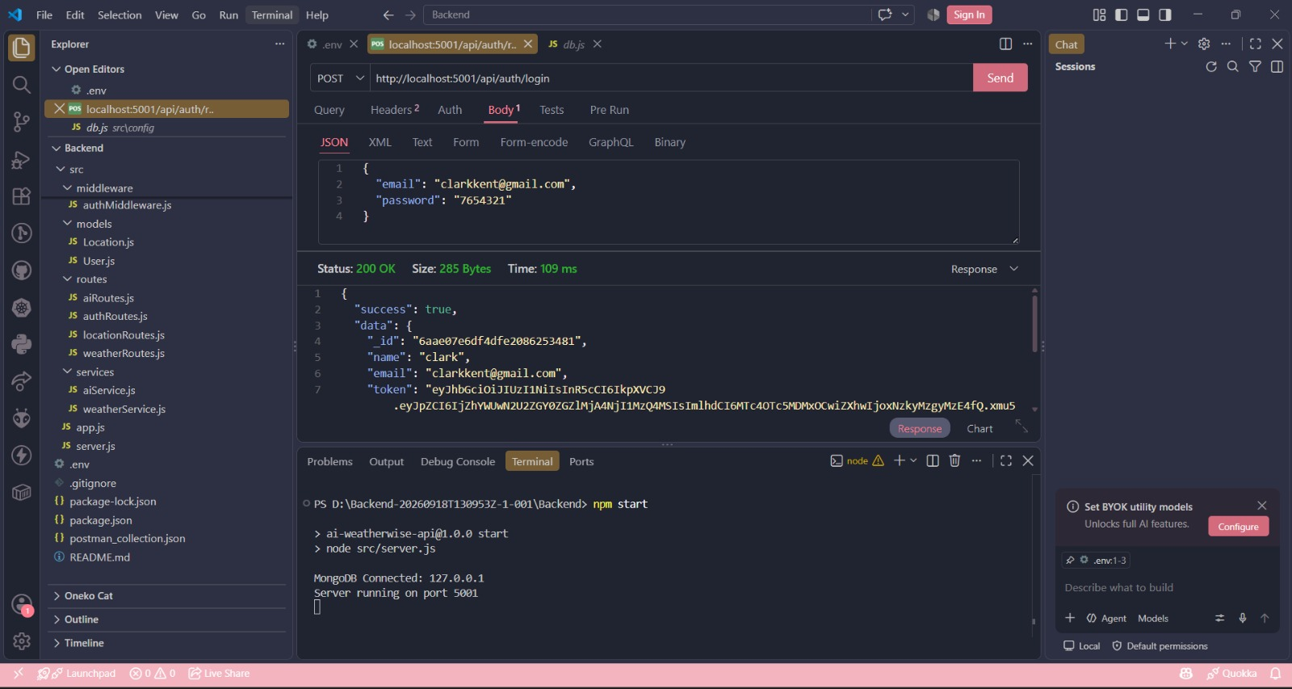

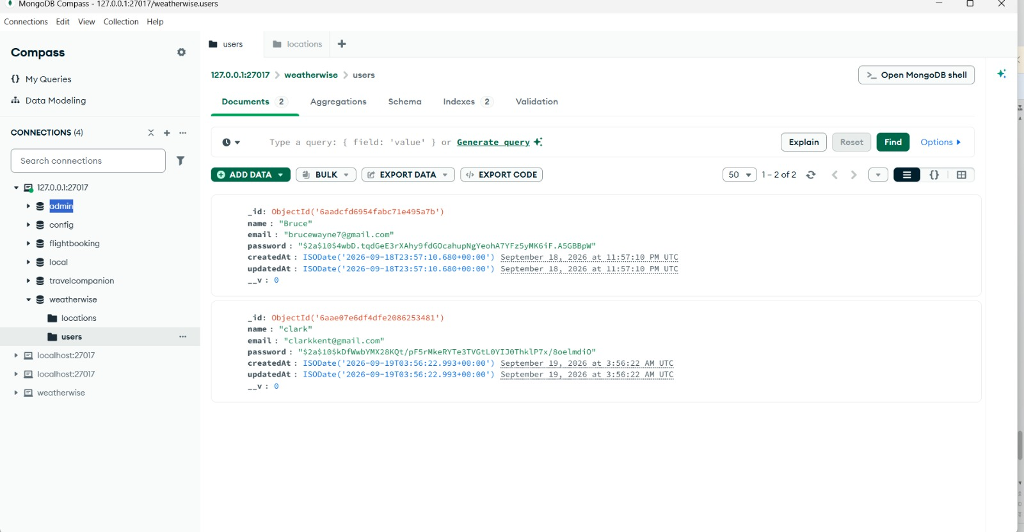

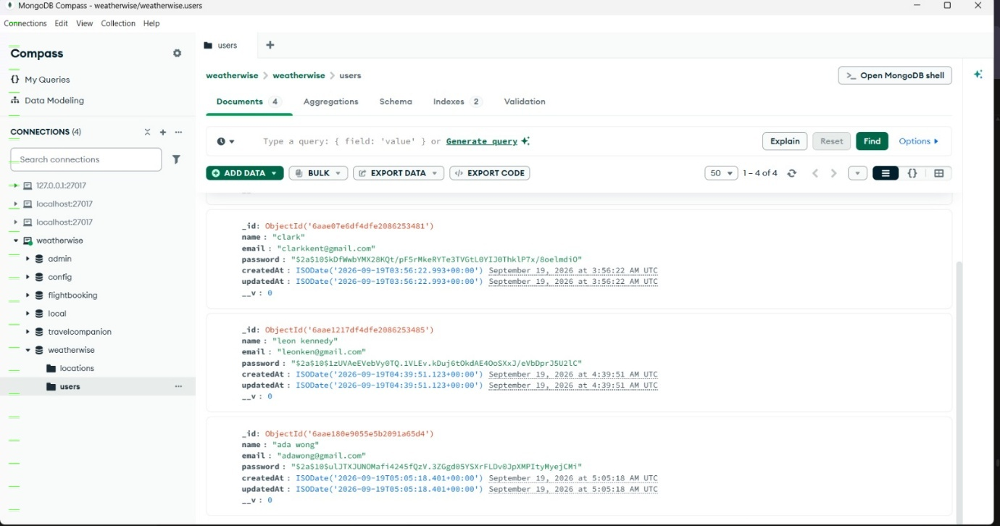

12. Known Issues

- AI-generated weather insights depend on the availability of the Gemini AI service.

- External API keys are required for full weather and AI integration.

- Internet connectivity is required to retrieve real-time weather information.

- API performance may be affected when external services are unavailable.

- Dependence on external weather services may affect weather data availability.

13. Future Enhancements

- Mobile application support for accessing weather insights on smartphones.

- Enhanced AI-powered personalized weather recommendations.

- Integration with additional weather data sources for more comprehensive forecasts.

- Improved weather prediction and analysis using advanced AI models.

- Support for more cities and locations with real-time weather updates.
Demo Video Link: https://drive.google.com/file/d/1esaNkQz12G5tjSEDeFN_coA37Cr3dmSb/view?usp=sharing

